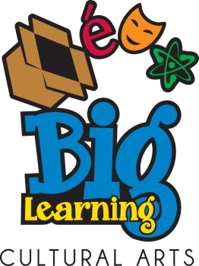
2026 Montgomery County
Cultural Arts Showcase
Sponsored by Big Learning

October 9th, 2025, 10 am – 3 pm
Carver Educational Center Auditorium
850 Hungerford Drive, Rockville, Maryland 20850

WHO ATTENDS: EVERYONE!!! Anyone interested is invited and encouraged to attend, including children (no unaccompanied children please). Please sign in each day that you attend. ADMISSION IS FREE!

Different performers each day. Each performance is 15 minutes. No lunch breaks. Schedule of performers will be available in late September at www.biglearning.org

ALL PERFORMERS PRESENTED AT THE SHOWCASES HAVE BEEN APPROVED BY THE SUPERINTENDENT’S COMMITTEE FOR PERFORMANCES IN MCPS.

DIRECTIONS: From the North, take Rt. 355 (Hungerford Drive) south. After passing Montgomery College, turn right at Mannakee Drive. Carver Educational Services Center is on your left. Park in the lot on your left before the building. Proceed to the North Entrance.
From 95, 495 and 270: Take 270 North toward Rockville and Frederick. Proceed to Exit 6A, Maryland 28 East (W. Montgomery Ave). Exit to Nelson Street/Montgomery College (go straight at the traffic signal). Follow Nelson Street 1.2 miles to the first traffic light at Mannakee Street and turn left. Carver Educational Services Center will be on your right. Pass the first set of driveways and turn right at the second set at the stop sign. Proceed to the North Entrance.
For more information contact:
Pam Loebach
301-706-9146
CAS@biglearning.org
www.biglearning.org

